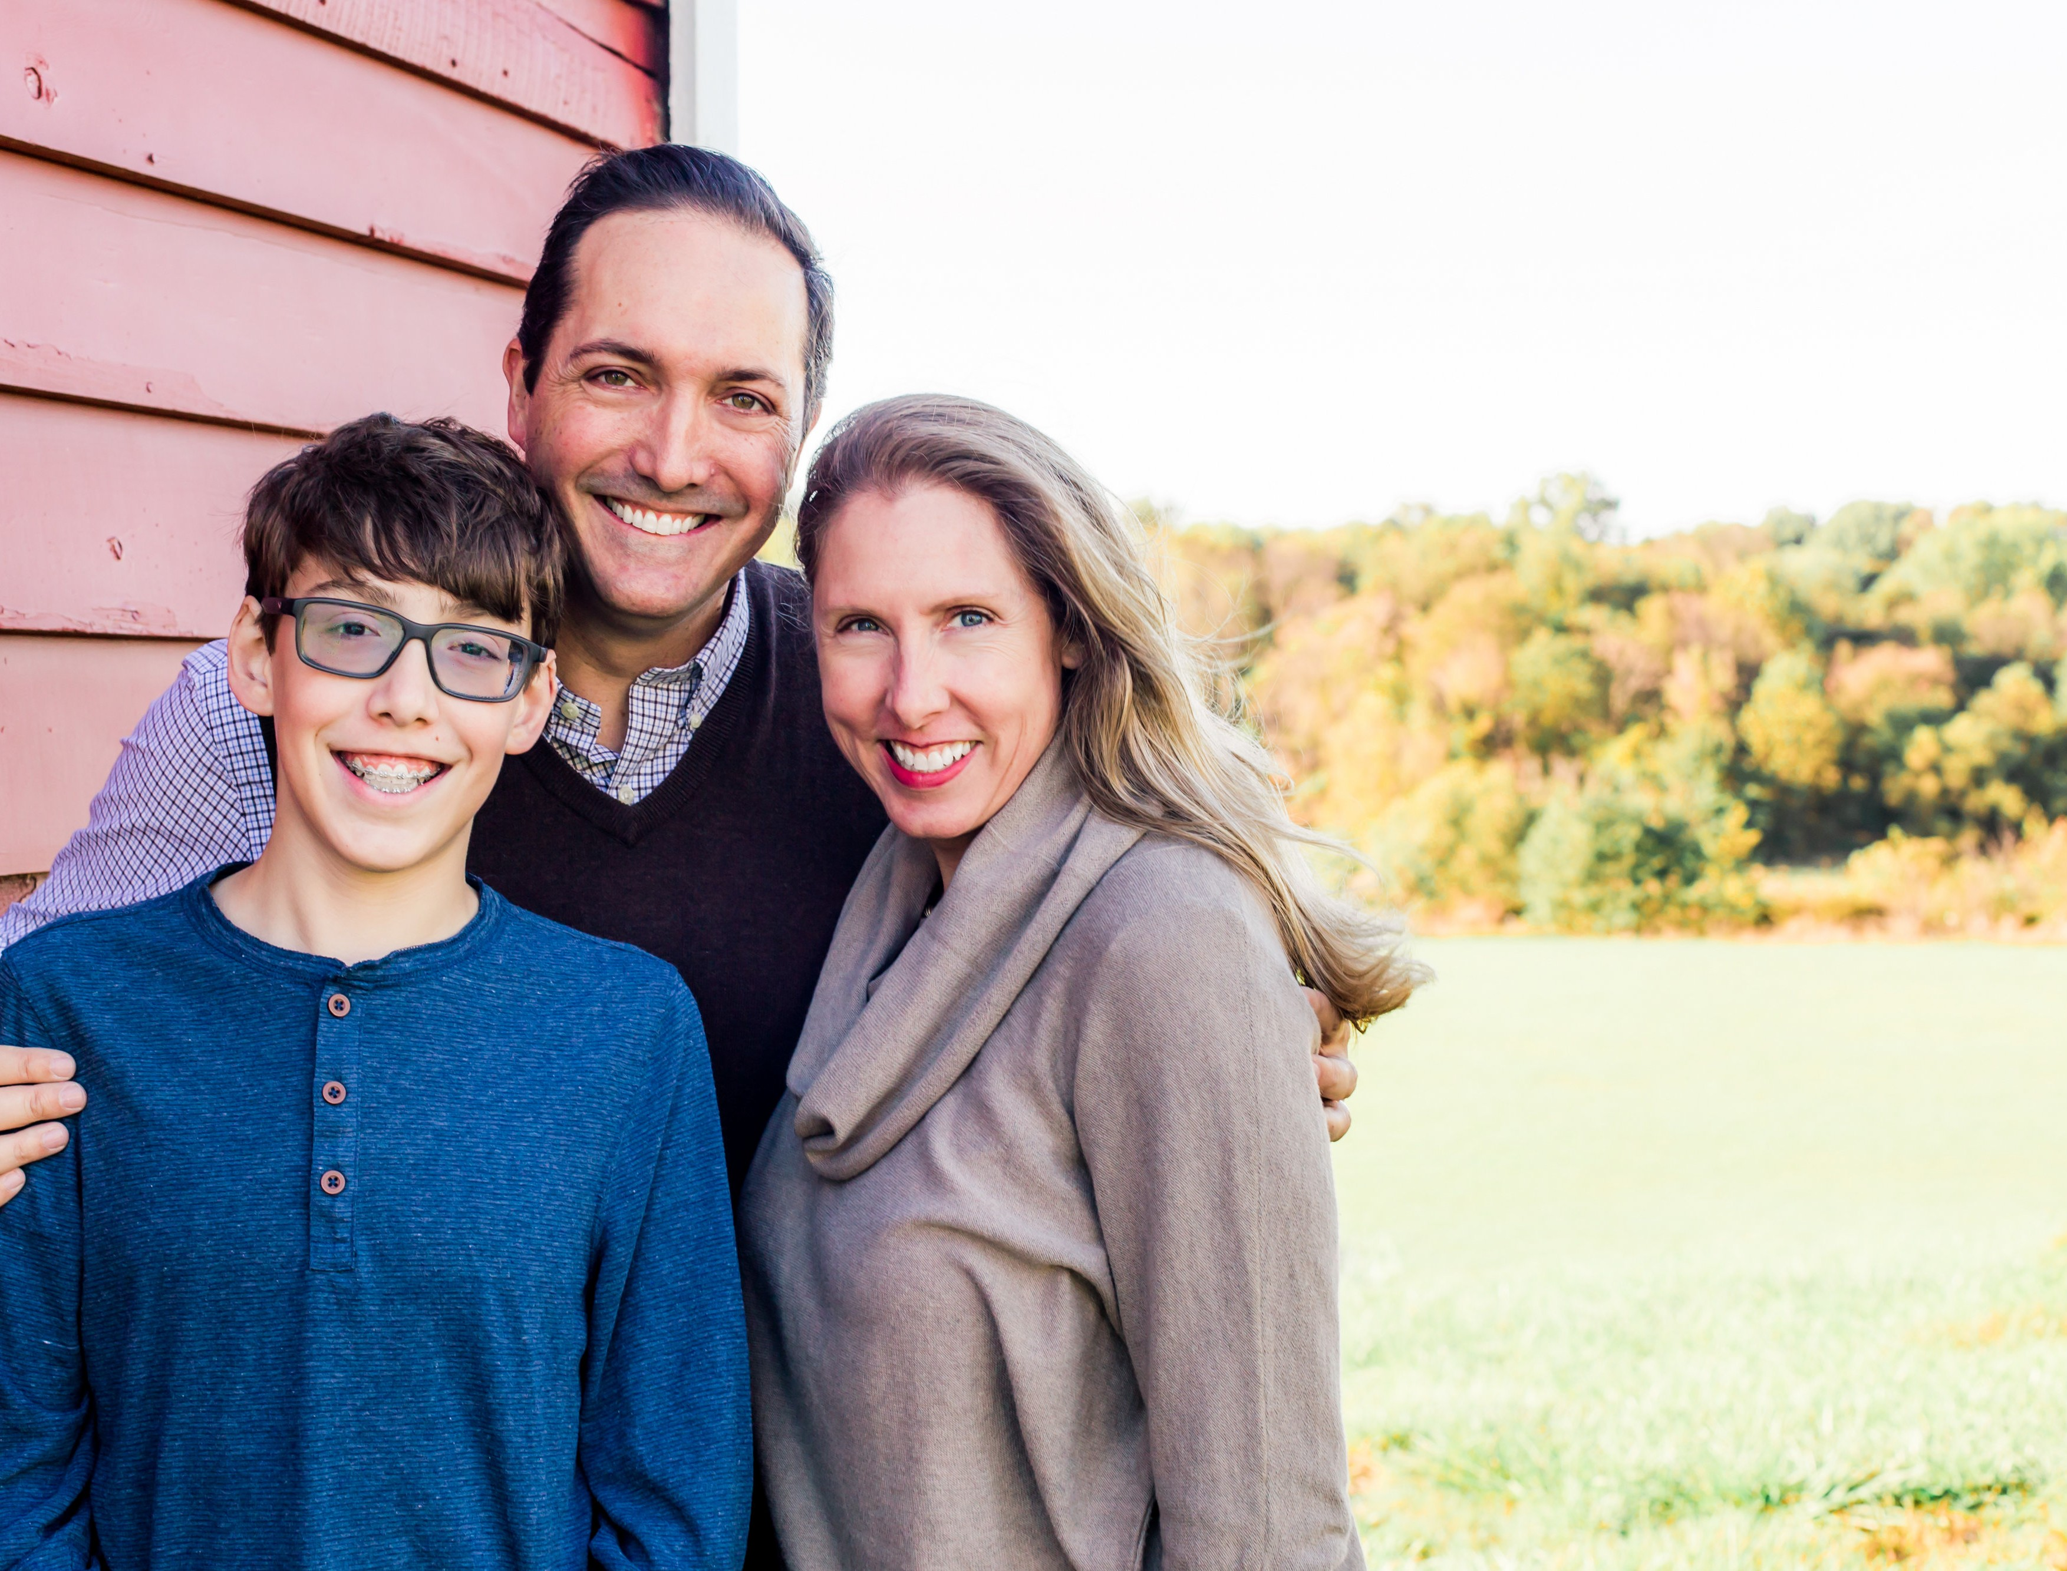

Pete, Cheryl & Jonathan
DellaSantina

The DellaSantinas live in Germantown, Maryland, a suburb of Washington D.C., where Pete has served as senior pastor for seven years. He and Cheryl are California natives. Pete was born and raised in Oakland and became a follower of Jesus in his late teens. Cheryl was born into a strong Christian home and grew up in San Luis Obispo until her family moved to the California Central Valley in her teens. They met at U.C. Davis and married in 1994.

Pete received his call to pastoral ministry when he was 25 years old. He and Cheryl moved to Danville, CA in 1996 to serve at Community Presbyterian Church while he pursued his Masters in Divinity at Fuller Seminary. Three years later, they moved to the seminary’s main campus in Pasadena where Pete finished his training and ordination and Cheryl supported them through her graphic design business.

In August 2001, Pete was called to pastor Knox Presbyterian Church in Minneapolis, MN and ministered there for nine years, also completing his Doctor of Ministry at Bethel Seminary in St. Paul. While living in Minneapolis, the Lord blessed Pete and Cheryl with the birth of their son, Jonathan.

Pete’s passion is communicating the unchanging message of the Gospel to an ever-changing culture, seeing people transformed by Jesus, and discipling fellow disciples toward maturity in Christ.

He enjoys going to the gym, reading, the great outdoors, date nights with Cheryl, helping with Jonathan’s Scout patrol, and his Monday night men’s Bible study group. Cheryl is his best friend and closest confidant. She has a passion for the transformative power of the Word of God and has led Bible studies and taught Sunday School. Since 2013 Cheryl’s time and energy has been invested in Jonathan’s education. She enjoys nurturing a peaceful home, working out, and time with friends. Their son Jonathan enjoys reading, computer programming, and almost anything STEM related. He accepted Christ when he was five years old and is active in the church youth group. This is Jonathan’s last year of homeschooling as he prepares to attend high school. He just earned the Life rank in Boy Scouts and is well on his way to being an Eagle Scout.

Pete’s mom lives in their family home in Oakland, CA while his two older brothers and their families live in the D.C. region. Cheryl’s mom and brother’s family live outside Boise. Pete and Cheryl’s dads have passed and all but one Jonathan’s cousins have either graduated or are still in college in Idaho, New York and Massachusetts.

